Nome completo do autor

**TÍTULO:**

**SUBTÍTULO (SE HOUVER**)

Dissertação/Tese submetido(a) ao Programa de ... da Universidade Federal de Santa Catarina para a obtenção do Grau de ... em ....

Orientador: Prof. Dr.

Coorientador (se houver): Prof. Dr.

Cidade

Ano

Ficha de identificação da obra elaborada pelo autor

através do Programa de Geração Automática da Biblioteca Universitária da UFSC.

|  |
| --- |
|  |
| A ficha de identificação é elaborada pelo próprio autor  Maiores informações em:  <http://portalbu.ufsc.br/ficha> |
|  |
|  |
|  |
|  |
|  |

Nome completo do autor

**TÍTULO: SUBTÍTULO (SE HOUVER)**

Esta Dissertação/Tese foi julgada adequada para obtenção do Título de “....” e aprovada em sua forma final pelo Programa ...

Local, x de xxxxx de xxxx.

________________________

Prof. xxx, Dr.

Coordenador do Curso

**Banca Examinadora:**

________________________

Prof.ª xxxx, Dr.ª

Orientadora

Universidade xxxx

________________________

Prof.ª xxxx, Dr.ª

Corientadora

Universidade xxxx

________________________

Prof. xxxx, Dr.

Universidade xxxxxx

Este trabalho é dedicado aos meus colegas de classe e aos meus queridos pais.

AGRADECIMENTOS

Inserir os agradecimentos aos colaboradores à execução do trabalho.

Xxxxxxxxxxxxxxxxxxxxxxxxxxxxxxxxxxxxxxxxxxxxxxxxxxxxxxxxxxxxxxxxxxxxxx.

Texto da Epígrafe. Citação relativa ao tema do trabalho. É opcional. A epígrafe pode também aparecer na abertura de cada seção ou capítulo.

(Autor da epígrafe, ano)

RESUMO

O texto do resumo deve ser digitado, em um único bloco, sem espaço de parágrafo. O resumo deve ser significativo, composto de uma sequência de frases concisas, afirmativas, e não de uma enumeração de tópicos. Não deve conter citações. Deve-se usar o verbo na voz ativa. Abaixo do resumo, deve-se informar as palavras-chave (palavras ou expressões significativas retiradas do texto) ou termos retirados de thesaurus da área.

**Palavras-chave:** Palavra-chave 1. Palavra-chave 2. Palavra-chave 3.

ABSTRACT

Resumo traduzido para outros idiomas, neste caso, inglês. Segue o formato do resumo feito na língua vernácula. As palavras-chave traduzidas, versão em língua estrangeira, são colocadas abaixo do texto precedidas pela expressão “Keywords”, separadas por ponto.

**Keywords:** Keyword 1. Keyword 2. Keyword 3.

LISTA DE FIGURAS

Nenhuma entrada de índice de ilustrações foi encontrada.

LISTA DE QUADROS

Nenhuma entrada de índice de ilustrações foi encontrada.

LISTA DE TABELAS

Nenhuma entrada de índice de ilustrações foi encontrada.

LISTA DE ABREVIATURAS E SIGLAS

ABNT – Associação Brasileira de Normas Técnicas

IBGE – Instituto Brasileiro de Geografia e Estatística

LISTA DE SÍMBOLOS



Yin Yang



Estrela de Davi em círculo

SUMÁRIO

1 INTRODUCTION 27

1.1 MOTIVATION 27

1.2 OBJECTIVES 31

1.2.1 Main Objective 31

1.2.2 Specific objectives 31

1.3 DISSERTATION STRUCTURE 31

2 SYSTEM MODELING 33

2.1 CLASSIC CONTROL APPROACH 33

2.2 MICRO INVERTER MODEL 34

3 CONTROL STRATEGIES 41

3.1 Frequency response 41

3.2 Nyquist plots and Nyquist stability criterion 42

4 CONCLUSÃO 67

REFERÊNCIAS 69

APPENDIX A – Influence of control strategies on the micro-inverter operation considering parasitic resistances of inductors 71

ANEXO A – Descrição 77

# INTRODUCTION

This chapter presents a motivation that justify the injection of current into the grid by a micro inverter as a chosen topic of this master thesis. Additionally, it explains the main proposal and the specific goals, as well as the general structure of this thesis.

## MOTIVATION

Historically, fossil fuel sources produces most of the energy that the world, that is, sources like oil, coal, and gas are responsible for most of the electric energy consumed worldwide. A major problem that this kind of energy presents is that such fuel sources are non-renewable. Another large drawback of fuel energy is the environmental issue. Fossil sources are known for releasing byproducts that pollute the environment around the center of production of electric energy.

An alternative for these forms of energy production is renewable, clean energy sources, such as wind, hydroelectric, or photovoltaic energy. Mainly due to their ecological appeal, but also because of the necessity of diversification of the electric generation sources, these alternate energy sources are gaining space in market.

Research, development, and applications have focused on these renewable sources that are being used more and more in isolated locations, residences, and great renewable generation facilities that are built to generate large amounts of electric energy from wind generators or photovoltaic panels.

Although hydroelectricity accounted for nearly 80 percent of the Brazil’s electricity generation in 2010, the government has been trying to diversify Brazil’s electricity generation fuel mix and reduce its reliance on hydropower to mitigate the risk of power shortages during times of severe drought.

Photovoltaic generation has presented itself in the spotlight in this context because of the large availability of this energy source and due to the aspects aforementioned.

Studies in the field of interconnection of small energy sources in the electric grid date from as early as 1970 in Brazil. Since then, several researches have been conducted addressing the concept of distributed generation (DG), a system in which an energy source, typically, a renewable one, injects power directly in the electric grid.

The connection of photovoltaic systems to the electric grid in residential applications is becoming a significant growing segment of the market of renewable energy sources. This operation has become regulated in Brazil since the publication of ANEEL regulation nº 482/2012, helping spread this kind of application.

Since the energy generated by a photovoltaic module is continuous and, usually, at a very low voltage (approximately 30 V), it is necessary to convert this energy in a way that it is compatible with grid characteristics (usually 220 Vrms alternated at 60 Hz).

Usually, to make the interface between the electric grid and the photovoltaic generator, power converters based on PWM (Pulse Width Modulation) are used. These converters demand the utilization of a low-pass filter on its output. Two power converters that are generally used for photovoltaic applications are string inverters and micro-inverters, and they differ because of the power processed, how many panels can be connected to them, the way they perform the maximum power point tracking (MPPT), among other characteristics.

Micro-inverter

One solution proposed to process photovoltaic energy is the micro-inverter. Since it is capable of connect a single module to the electric grid, this equipment brings some advantages over other solutions. For instance, the photovoltaic system has a modularity characteristic. Other advantage presented by a micro-inverter is the possibility of extract the maximum power point of each individual module, overcoming problems of shadowing that may cause a much larger loss of power in string systems.

A micro-inverter is a device that is capable of converting the continuous current (dc energy) generated by a single photovoltaic module into alternated current (ac energy) compatible with the electric grid energy. Additionally, two or more micro-inverter´s outputs can be connected in parallel so that the energy injected into the grid can be increased, assuring the modularity characteristic of this type of converter.

The main difference between micro-inverters and string inverters is that this last device is designed to convert the energy from a whole string of photovoltaic modules connected in series or parallel. Although string inverters are usually less expensive than micro-inverters for the same amount of energy generated and demand low-pass filters with a wider pass band, making its control easier to design, micro-inverters present some advantages when compared to string inverters, such as:

1. Cost of installation flexible and depending on the amount of energy intended to be generated;
2. Modularity – Ease of expansion due to the fact that photovoltaic modules work individually;
3. Individual maintenance– no need to disconnect more than one module when it presents a flaw.
4. Efficiency – as each module operates individually, the MPP is also individual, which reduces losses caused by, for instance, shadowing problems.

A static gain between 10 and 20 must be provided by a micro-inverter since the output voltage of a photovoltaic module is significantly lower than the peak voltage of the electric grid. That characteristic can be achieved using a single-stage or a double-stage micro-inverter.

[INSERT FIGURE HERE]

In the micro-inverters of the last case, the first stage, dc-dc conversion, presents high gain in order to elevate the voltage from a low dc voltage, usually around 25~30 V, to a value above the peak voltage of the grid voltage, as well as track the point of maximum power of the module.

The second stage is the conversion of the dc voltage to ac, grid compatible voltage so that the energy generated by the photovoltaic module is delivered to the electric grid in conformity to the electric company regulations.

Regulations

In Brazil, the regulating resolution 482/2012 of ANEEL regulates all applications involving interconnection of micro-generation and the electric grid characterizing distributed generation. This regulation defines the range of power in which a generator is characterized as distribution generation, as well as the procedure of how the energy injected to the grid must be accounted for the owner of the generator installation.

In relation to the regulations that dictates the minimum criteria to realize the grid connection, ANEEL specifies that the generator unit must adequate to the regulations imposed by PRODIST (procedure of distribution of electric energy into the national electric system), the Brazilian regulations and, in some cases, the international regulations.

PRODIST is a set of documents, divided in ten (10) modules, regulating and standardize all activities related to the distributing systems in Brazil. Each of its module deals with a specific part of the regulations imposed to all parties involved with an electric energy distribution grid.

To the matter of this dissertation, module 8 is the most relevant. Module 8 of PRODIST deals with the minimum requirements related to the quality of the electric energy that will be delivered by the company responsible by the electric grid. This module states that the total voltage distortion (TVD), given by EQ. XXX, in systems that operate with a voltage under 1 kV must have a maximum value of 10%, respecting limits of odd, even and multiple of three harmonics. These limits are shown in TABLE III.

$$TVD_{n}\%=\frac{\sqrt{\sum_{n}{V_{n}^{2}}}}{V_{1}}100\%$$

|  |  |
| --- | --- |
| Harmonic | Limit |
| Total Voltage Distortion | $$10\%$$ |
| Non-multiple of 3 Even | $$2,5\%$$ |
| Non-multiple of 3 Odd | $$7,5\%$$ |
| Multiple of 3 | $$6,5\%$$ |

Module 8 of PRODIST also determines the maximum frequency variation acceptable under which the system must operate normally. It states that (a) the frequency of the grid must be within a range of 59.9 Hz and 60.1 Hz and (b) values of frequency below 59.5 Hz and above 60.5 Hz cannot last more than thirty seconds.

If those requirements are met, then the micro-inverters connected to the grid must obey a series of quality requirements for the current harmonics that is injected to the grid.

NBR 16149/2013 estipulate the limits the harmonic injection into the grid to photovoltaic systems. These limits are expressed in TABLE III.

|  |  |
| --- | --- |
| Harmonic | Limit |
| Odds | |
| 3a a 9a |  |
| 11a a 15a |  |
| 17a a 21a |  |
| 23a a 33a |  |
| Even | |
| 2a a 8a |  |
| 10a a 32a |  |

NBR 16149/2013 does not differ harmonics of the grid itself from harmonics from commutation of the converter. Therefore, in order to meet the limits of distortion established, the output filter implemented in the micro-inverter output must attenuate both harmonics: Harmonics caused by commutation of the converter as well as harmonics reflected from the grid voltage itself.

Filter in the output of the inverter is implemented to diminish harmonics multiple of commutation frequency.

To help mitigate harmonics on the fundamental frequency and its multiples, an adequate control strategy must be implemented to compensate the current that is injected into the grid.

Many control techniques have been implemented with the goal of optimizing the form of the current that is injected into the grid. Some are simple and easy to implement. Others are more complex and demand more processing power of the microcontroller used.

## OBJECTIVES

The theme of this dissertation is, therefore, to implement and compare some of the techniques most used in the control of the current injected in the electric grid by a micro-inverter connected designed to be installed with a photovoltaic module. Thus, the objectives of the work presented on this document consist of:

### Main Objective

* To compare different current control techniques in a 250 Watts photovoltaic micro-inverter.

### Specific objectives

* To study the proposed control techniques to control the current injected in the grid;
* To implement each of these techniques digitally in a micro-controller;
* To test the digitally implemented control techniques in a Hardware in the Loop device in order to validate the control laws;
* To obtain experimental results showing the current’s THD and the system’s Power Factor of the micro-inverter with each control technique;
* To obtain experimental results showing the dynamic responses of each of the control techniques;

## DISSERTATION STRUCTURE

This dissertation is formed by FFFFFF chapters, FFFFFF attachments, and FFFFF appendices.

Chapter 1 – Introduction explains the motivation of the chosen subject for this work. It also covers some basics of the operation of power converters and micro-inverters to photovoltaic applications. The regulations for the operation of micro-inverters connected to the grid are also briefly discussed in this chapter.

Chapter 2 – Blablabla

Chapter 3 – Blablabla

Chapter 4 – Blablabla

# SYSTEM MODELING

This chapter presents the procedure to obtain the dynamic model of the micro inverter that was studied during the development of this dissertation

## CLASSIC CONTROL APPROACH

The block diagram illustrated by Figure 2.1 represents a typical example of a Single Input – Single Output (SISO) feedback control system:



Figure 2.1. SISO feedback control system

Where:

 – is the transfer function that represents the system model,

 – is the transfer function that represents the system control,

 – is the feedback dynamics,

 – is the reference signal,

 – is the output signal.

A reference signal is compared to the feedback variable and an error signal is generated. Then the error signal is sent to the system control block, which provides a control action. The control action is responsible to act in the system in order to bring the output variable to a value as close as possible to the reference signal, i.e. reducing the deviation to zero or a small value.

In order to design the control, it is necessary to know the static and dynamics characteristics of every element that composes the system to be controlled. Thus, one must obtain the mathematic model that represents the converter used in this application.

## MICRO INVERTER MODEL

According to (KENSKI) the converter can be separated in three different parts: DC stage, switching stage, and AC stage. Figure 2.2 represents a model of the circuit for the monophasic micro inverter with damped LCL filter.

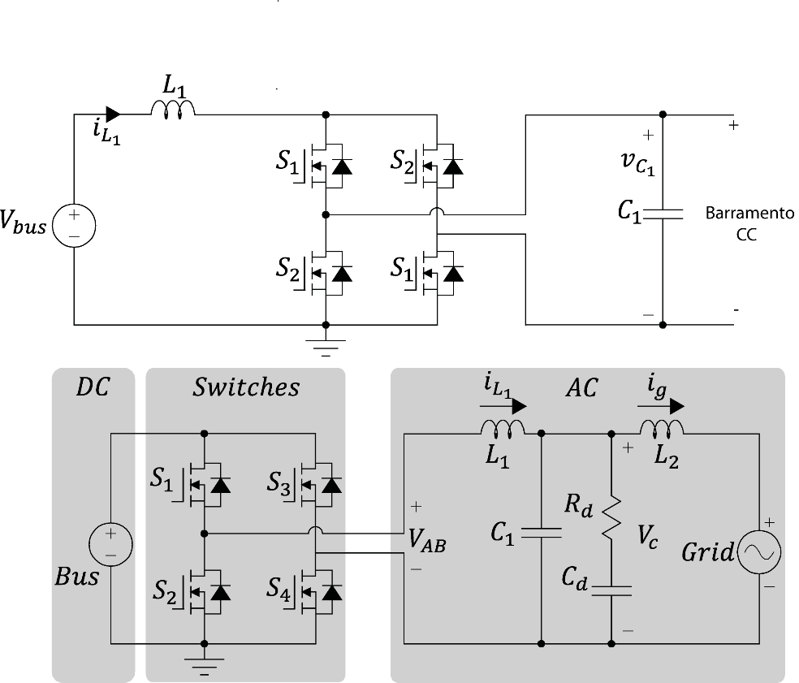

Figure 2.2. Circuit of converter with damped LCL filter, Source: [1]

The conventional classic modeling approach cannot deal with the circuit represented by Figure 2.2 since it is non-linear due to its switching elements.

The first step in modeling the converter is to substitute the switching elements of the converter by their equivalent large signal average circuit model. By doing that, one eliminates the non-linear characteristic of the commutated circuit and obtains a model that has a linear behavior when operating near an equilibrium point.

Figure 2.3 shows the circuit that represents the equivalent average circuit of the full-bridge inverter. This circuit is not yet a linear model representation since the controlled voltage and current sources are products of two time variant variables ( and) and ( and).



Figure 2.3 - Average circuit

In order to obtain a linear representation for the full-bridge inverter one must use the small-ripple approximation [2]. This technique linearize the time-variant variables around an operation point, considering that these variables do not vary from that point unless by some small disturbances. Equations , , and represents these approximations:

This technique consists in assuming that the capacitor`s voltage and inductors´ current have a small ripple that can be considered a DC value.







Where ,, and are small deviations around the operating point.

Using these approximations, the current dependent source in the average circuit may be written as Equations and :





The order zero term of Eq. represent the DC operating point. The first order terms are the terms that impose dynamics in the converter.

Since and  are, by definition, very small deviations, the second order term of Eq. above, which is a product of two very small values, is even smaller and can be discarded from the equation.

Likewise, the voltage dependent source in the average circuit may be written as Equations and :





The zero order term of represent the DC operating point. The first order terms are the terms that impose dynamics in the converter.

Since  and  are, by definition, very small deviations, the second order term of Eq. above, which is a product of two very small values, is even smaller and can be discarded from the equation.

The considerations made above yield EQUATION X, which represents the current dependent source, and EQUATION X, which represents the voltage dependent source of the circuit in FIGURE X.

$$d\left(t\right).i_{L1}\left(t\right)=\underset{order 0}{\underbrace{D.I_{L2}}}+\underset{order 1}{\underbrace{D.{\tilde{i}}_{L2}+I_{L2}.\tilde{d}}}$$

$$d\left(t\right).V_{bus}\left(t\right)=\underset{order 0}{\underbrace{D.V_{BUS}}}+\underset{order 1}{\underbrace{D.{\tilde{v}}_{bus}+V_{BUS}.\tilde{d}}}$$

By separating the zero order terms from the first order terms, the circuit presented in Figure 2.3 - Average circuitFigure 2.3 can be redrawn as the circuit presented in Figure 2.4.

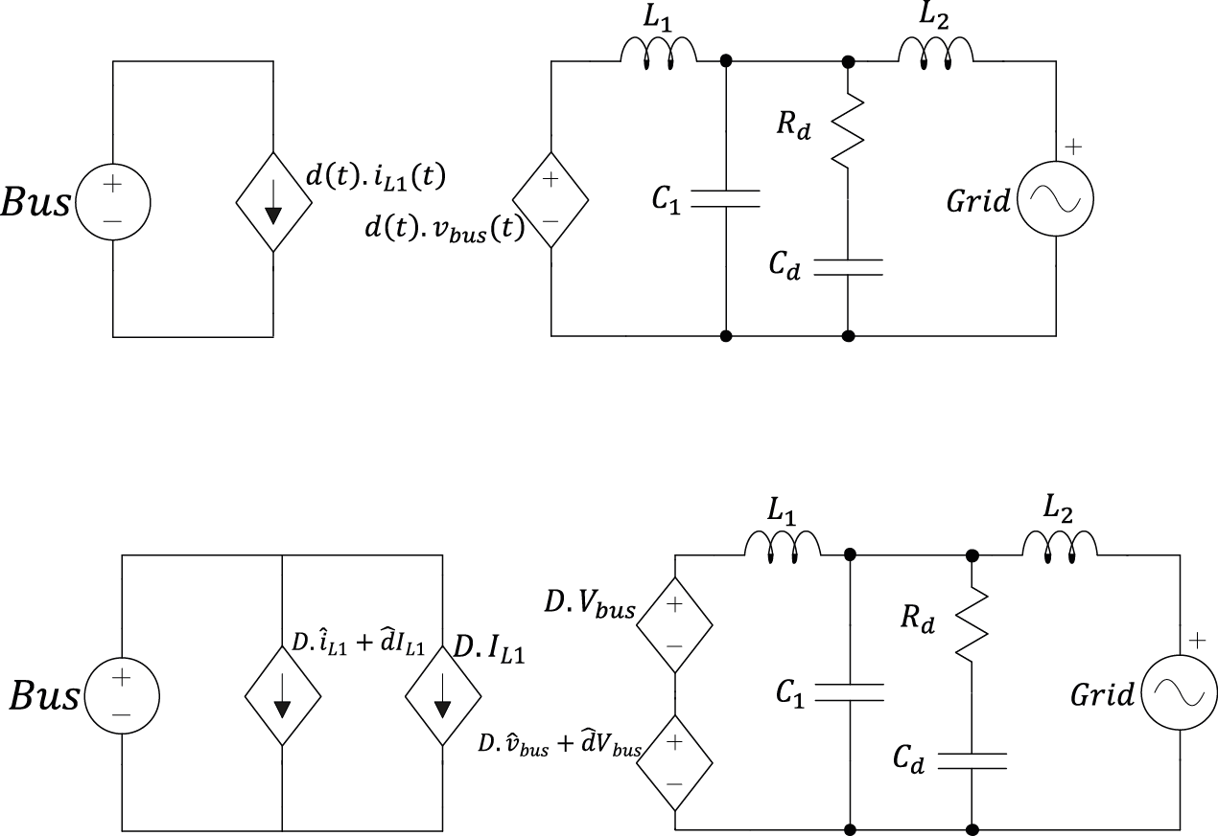

Figure 2.4 - Linear average circuit

As this circuit is considered to be linear around its operating point, all theories of linear systems can be done in its analysis. The next step is using the superposition principle to separate the circuit according to the sources that feed it.

The superposition principle, also known as superposition property, states that, for all linear systems, the net response caused by two or more stimuli is the sum of the responses that would have been caused by each stimulus individually.

A function  that satisfies the superposition principle is called a linear function. Superposition can be defined by two simpler properties; additivity (Eq. ) and homogeneity (Eq. ).





By applying the superposition property in the circuit of Figure 2.4, one can separate it in two different circuits. In Figure 2.5, it is considered the DC sources, that is, the sources that have a fixed, constant value. Through the analysis of this circuit, one can extract the static characteristics of the converter.

In Figure 2.6 considers the AC sources, that is, the sources that vary through time, sources that have disturbances associated. Through the analysis of this circuit, one can extract the dynamic characteristics of the converter. It is through the dynamic analysis that the control of the converter is to be designed.



Figure . - DC circuit



Figure 2.6 - AC circuit

In order to find the transfer function that represents the dynamic behavior of the circuit represented in Figure 2.6, the impedance of the damped-LCL filter is to be found.

Applying Laplace, one can replace the elements of the damped LCL filter by impedances dependent of the frequency variable (). The grid source can be considered as a short-circuit due to the superposition principle mentioned above. The equivalent model used to find the transfer function of the grid current related to the duty cycle is shown in Figure 2.7.



Figure 2.7 - AC circuit considering filter impedance

The impedances of this circuit can be mathematically described, utilizing the Laplace variable , by Equations , , , and









It is possible to associate the capacitive impedances in order to obtain a single damped capacitive branch. This association yields EQUATION X:



By analyzing circuit of Figure 2.7, the transfer function that relates the duty cycle with the current in the second inductor is given by:



Rewriting this transfer function in terms of the passive elements yields EQUATION X:





In order to validate this transfer function, the circuit shown in Figure 2.2 is simulated in the software PSIM using the tool ‘AC sweep’. The comparison between the AC sweep response and the transfer function bode diagram is shown in Figure 2.8.

This comparison shows that, for a large frequency range, the results are very similar. Therefore, the transfer function obtained through the mathematic modeling is considered to be valid.

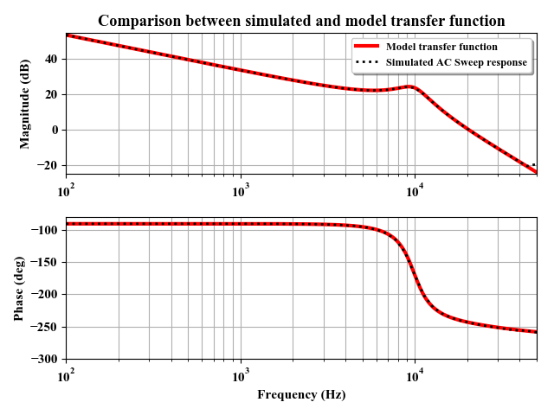

Figure 2.8 - Frequency response comparison between circuit and model

# CONTROL STRATEGIES

## Frequency response

Frequency-response analysis and design of a linear control system is based on Nyquist stability criterion, from which absolute, as well as relativity stability of linear closed-loop systems can be investigated from a knowledge of their open-loop frequency-response characteristic.

In general, when designing a closed-loop system, one adjusts the frequency-response characteristic of the open-loop transfer function by using several design criteria in order to obtain the desired transient-response characteristics for the system.

The Bode diagram, which consists of two graphs, can usefully represent the frequency-response of a system: a curve of the logarithm of the magnitude of a sinusoidal transfer function and a curve of the phase angle; both curves are plotted against the frequency on a logarithmic scale. The logarithm magnitude graph’s representation is standardized as , where the base of the logarithm is 10. Decibel is its unit and it is abbreviated dB.

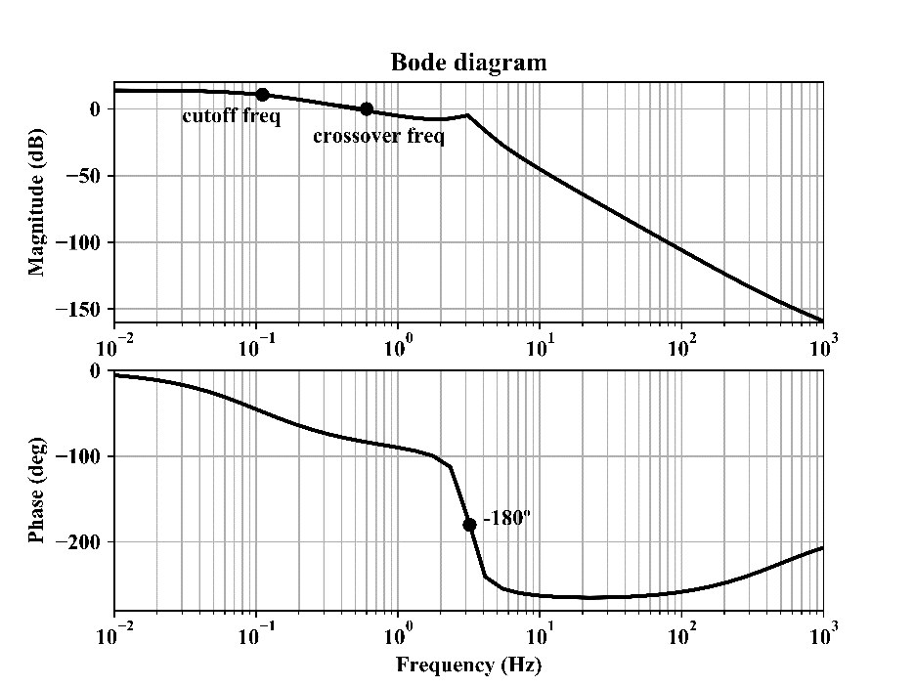

Figure 3.1 - Bode diagram for an arbitrary third order system

Some interesting characteristics that can be extract from the Bode diagram are the cutoff frequency and the bandwidth.

The cutoff frequency can be defined as the frequency at which the magnitude of the closed-loop frequency response is  below its zero-frequency value. The closed-loop system filters out the signal components whose frequencies are greater than the cutoff frequency and transmits those signal components with frequencies lower than the cutoff frequency.

The frequency range  in which the magnitude of the closed loop does not drop  is called the bandwidth of the system. The bandwidth indicates the frequency where the gain starts to fall off from its low-frequency value. Thus, the bandwidth indicates how well the system will track a sinusoidal input.

The rise time and the bandwidth are inversely proportional to each other. That is, the rise time increases with the decreasing damping ratio  . On the other hand, the bandwidth decreases with increasing . The specification of the bandwidth may be determined by the following factors:

1. The ability to reproduce the input signal. A large bandwidth correspond to a small rise time, or a fast response.
2. The necessary filtering characteristics for high-frequency noise.

For the system to follow arbitrary inputs accurately, it is necessary that it have a large bandwidth. From the viewpoint of noise, the bandwidth should be as narrow as possible. Thus, there are conflicting requirements for the design of a good control system and a compromise is necessary. In addition, systems with large bandwidth require high-performance components and the cost of the components usually increases.

## Nyquist plots and Nyquist stability criterion

The Nyquist plot of a transfer function is the plot of the magnitude versus the phase angle of that transfer function in polar coordinates as the frequency varies from zero to infinity.

One advantage of Nyquist plot is that it shows, in only one graph, magnitude and phase of a transfer function through the whole frequency range. A disadvantage is that it does not clearly provide details of the contribution given by any of the system’s singularities.

Considering a system given by the closed-loop transfer function represented by :





For stability, all roots of the characteristic equation shown in must lie on the left-half s-plane.



The Nyquist stability criterion relates the open-loop frequency-response  to the number of zeros and poles of that lie in the right-half s-plane. This criterion can be state as follows:

If an open-loop system has **p** poles in the right-half s-plane, then, for stability,  locus as a representative point *s* traces out the Nyquist path in the clockwise direction must encircle the  point **p** times in the counterclockwise direction.

Considerations on the Nyquist stability criterion are numbered:

1. Nyquist stability criterion can be expressed as:



Where

 = number of zeros of  in the right-half s-plane;

 = number of clockwise encirclements of the  point;

 = number of poles of in the right-half s-plane.

If  is not zero, then, for a stable control system,  must be equal zero, or , which means that the locus of the system must encircle the point  in the counterclockwise direction  times.

If  does not have any poles in the right-half s-plane, then  must be equal for stability

1. Multiple-loop systems demand special attention when testing their stability by Nyquist criterion since they may include poles in the right-half s-plane. Simple inspection of the encirclements of the  point may not be sufficient in determining whether these kind of systems are stable or not. In such cases, the application of Routh-Hurwitz stability criterion to the denominator of  is recommended.
2. If the locus of  passes through the  point, then the zeros of the characteristic equation, or the closed-loop poles, are located on the imaginary axis. This is not desirable for a control system since that means the system is marginally stable and will present considerable oscillation operating in steady state.

Figure 3.2 shows Nyquist plots of a third-order system given by Eq. for three different values of the open-loop gain . For a small value of the gain , the system does not encircle the point  and is, therefore, stable. For a large value of the gain , the system is unstable, since its plot encircle the point  once. For a certain value of , the plot of the system passes exactly through the point . That means that, for this value of , the system is on the verge of instability and will exhibit sustained oscillations.



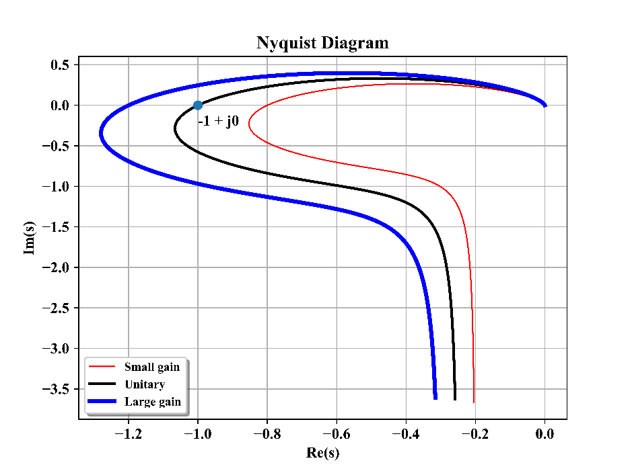

Figure 3.2 - Nyquist plot of an arbitrary third-order system

Phase margin is the amount of additional phase lag at the gain crossover frequency () required to bring the system to the verge of instability. The gain crossover frequency is the frequency at which de magnitude of the open-loop transfer function is unity. The phase margin is given by Eq.:



Gain margin is the reciprocal of the magnitude of the system at the frequency at which the phase angle crosses (). The margin gain  is given by Eq. .



The gain margin of first- and second-order systems are infinite, since the Nyquist plots of such systems do not cross the negative real axis and, therefore, never crosses the point .

The phase and gain margin of a control system are a measurement of the closeness of the Nyquist plot to the  point. Therefore, these margins may be used as design criteria. For a minimum-phase system, both phase and gain margin must be positive in order for the system to be stable.

Proper gain and phase margins ensure satisfactory performance of the system against parametric variations in the system’s components. An adequate value for the gain margin is at least . For the phase margin, it is recommended something between  to .

The requirement of the phase margin to be between  to means that, in the Bode diagram, the slope of the log-magnitude curve will be more gradual than  in the crossover frequency. It is desirable that the slope of the magnitude curve be  since that assures that the system is stable. If the slope is , the system could be either stable or unstable, but even if the system is stable, the phase margin is small. If the slope is - or steeper, the system will be unstable.

## Internal model principle

The concept of internal models plays a crucial role in regulator problems. The internal model principle can intuitively be expressed as: ‘Any good regulator must create a model of the dynamic structure of the environment in the closed loop system’

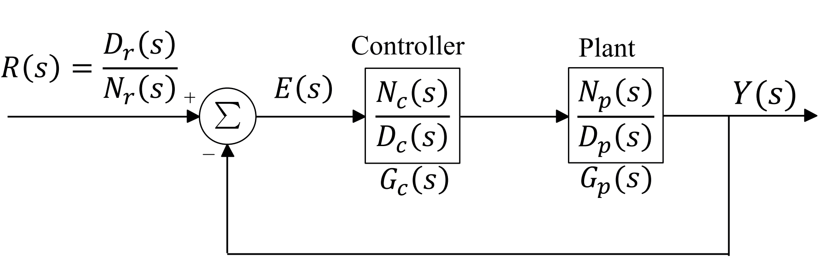

Figure 3.3 - Block diagram of a closed-loop control system

In the configuration depicted in Figure 3.3, where the poles of R(s) are in the right half plane,



if and only if:

1. the closed-loop poles are in the open left-half plane;
2.  is a factor of the open-loop characteristic polynomial , that is, there is a polynomial, say , such that .

The first condition assures that the closed-loop system is asymptotically stable. The second condition means that the tracking controller must be chosen in such way that the open-loop transfer function, , contains a model of the reference signal to be tracked.

That is, if the requirement for the system is that it tracks a reference with a DC value, the open-loop transfer function of that system must contain the model of a step ( );

If the requirement for the system is that it tracks a sinusoidal reference, the open-loop transfer function of that system must contain the model of a sine () or cosine .

The internal model principle can be summed up as follows: “Any good tracking controller must stabilize the closed-loop system and must contain a model of the reference signal”.

**Design of control systems in the frequency domain**

The design of control systems based on the Bode diagram approach is useful for several reasons, including:

1. The error constants  can be easily identified by the low frequency asymptote of the magnitude curve;
2. Specifications of transient response can be related to characteristics of the Bode diagram like *phase margin*, *gain margin*, *bandwidth*, and so forth.
3. The design of a compensator to satisfy given specifications can be carried out in the Bode diagram in a simple and straightforward manner.

## Determination of a Proportional compensator

There is a principle in engineering called ‘Parsimony’. It is also known as ‘the minimum effort Law’. Is states that, when looking for a solution to solve a given problem, one must always adopt the easiest possible solution that will bring satisfactory results.

When dealing with control systems, the simpler possible control strategy that someone can design is a simple proportional gain that is applied to an error signal.

Equation gives the transfer function that describes a Proportional compensator.



In order to design the proportional compensator, one must just determine the value of the  gain with the objective of attending a set of specifications.

Since this control strategy can adjust only gain of the plant, one can specify the crossover frequency () and the magnitude of the PI transfer function is given by Eq.:



Therefore, the proportional gain of this control strategy is given by Eq. .



The phase margin, Eq , is going to be the phase of the plant at the crossover frequency. This parameter cannot be changed with the use of a proportional compensator.



## Determination of a Proportional-Integral (**PI**) compensator

Equation gives the transfer function that describes a PI-compensator.



In order to design the PI-compensator, one must determine the value of the parameters  and  with the objective of attending a set of specifications. Two of the specifications that may be taken into consideration to determine the PI parameters are the desired crossover frequency () and the phase margin ().

As the control system is being designed following a frequency approach, the real portion () of the Laplace variable () can be considered to be zero and only the imaginary portion is considered (). Therefore, Eq. becomes Eq.



The magnitude of the PI transfer function is given by Eq.:



The phase of the PI transfer function is given by Eq. .



Applying and into gives Eq. and Eq. .





## Determination of a Proportional-Resonant (**PR**) compensator

The procedure for determination of the parameters of a PR compensator is very similar to that of a PI compensator. One must only substitute the transfer function that describes the PI compensator for the transfer function of a PR compensator.

The resonant portion of a PR compensator may be a frequency representation of a cosine function, as represented in EQUATION XXX.



A PR compensator is given by the sum of a proportional and a resonant gain. Equation represents a PR compensator.



Where:

 is the proportional gain;

 is the resonant gain;

 is the resonant frequency, usually 

Equation represents an alternative form of the transfer function that describes a PR-compensator.



Where:





In order to design the PR-compensator, one must determine the value of the parameters  and  with the objective of attending the same set of specifications cited in the case of the PI compensator.

As the control system is being designed following a frequency approach, the Laplace variable () of is substituted by the frequency variable (). Therefore, Eq. becomes Eq. .

 

Eq. gives the magnitude of the PR transfer function:



Eq. gives the phase of the PR transfer function.



Applying and into Eq. gives Eq. and Eq. .





**Procedure for determination of a Proportional-Multi-Resonant (MR) compensator**

In general, when a micro-inverter is connected to the grid, the current delivered by it to the grid is a sum of a sinusoidal waveform in the grid frequency along with several others frequencies that are multiple of the grid frequency.

The frequencies that are multiple to the grid fundamental frequency, also referred to as harmonic frequencies, cause a distortion in the current waveform that is delivered to the grid by the micro-inverter.

The idea behind the implementation of a Proportional + Multi-resonant controller, once again, based on the Internal Model Principle, is that the control should be able to compensate errors and track reference signals that have more than one frequency of interest.

In this case, the frequencies of interest are the harmonic frequencies of the grid voltage that cause the distortion in the current waveform aforementioned.

A proposed form for a MR compensator is given by Eq. .

The resonant gain $K_{r}$ is pondered by the order of the harmonic associated with it. That is, the gain  decreases proportionally as the order of the harmonic to be compensated increases.



Where

 is the proportional gain

 is the resonant gain

 is the frequency of interest to be tracked by the control system;

 is the highest frequency to be tracked by the control system;

 is the resonant frequency given by .

This proposition is interesting in the point of view of design procedure of control because it has only two parameters to be determined.

Therefore, In order to design the MR-compensator, one must determine the value of the parameters  and  with the objective of attending the same set of specifications cited in the cases aforementioned of PI and PR compensators.

In order to find these parameters as a function of the crossover frequency  and the phase margin , Eq. can be rewrote as follows.









Rewriting Eq. in terms of products and sums depending on the harmonic orders that compose the compensator yields Eq. .



Where

;

;

Considering the Laplace variable  in the frequency domain, the term corresponding to the real part is . Laplace variable is simply . Eq. can be written in the form of Eq. .



Manipulating Eq. in terms of its magnitude and phase yields Eq. and which give  and, as function of the cutoff frequency.





## Procedure for determination of a Repetitive compensator

Traditionally, in control system theory, the design of the controllers are made based on the internal model principle.

In order to deal with periodic references and disturbances, the internal model principle is the basic principle considered by resonant and repetitive controllers. In fact, to perfectly track or reject a sinusoidal signal with determined frequency, the controller must contain a pair of poles at  in the imaginary axis.

An alternative to multi-resonant controllers to cope with periodic signals is the repetitive controller. A repetitive feedback control system is based on the concept of iterative learning control, and it has been widely used for many practical industrial systems, such as manufacturing [REFERENCE], robotics [REFERENCE], as well as in UPS (uninterruptable power source). In these controllers, error between reference signal and the measured output signal over one fundamental cycle is used to generate a new reference to the next fundamental cycle.

A repetitive controller is mathematically equivalent to a parallel combination of an integral controller, an infinite number of resonant controllers, and a proportional controller. [REFERENCE]

It has the advantage of being simpler to implement than it is to implement several proportional-resonant controllers in parallel. However, the microcontroller in which this control technique is implemented must storage a large number of output and error samples that are used to calculate the control variable to be applied to the plant. Another disadvantage of repetitive controllers is that it creates resonance gain peaks in harmonics of high frequencies, which can lead to instability.

A low-pass filter is generally used to attenuate these high frequency gain peaks but if the bandwidth of the plant is small, the implementation of this filter will reduce the low frequency resonance gains and deteriorate the performance of the repetitive controller. [REFERENCE]

**Direct repetitive controller**

A proposed topology for a repetitive control system is shown in Figure 3.4, according to [REFERENCE]

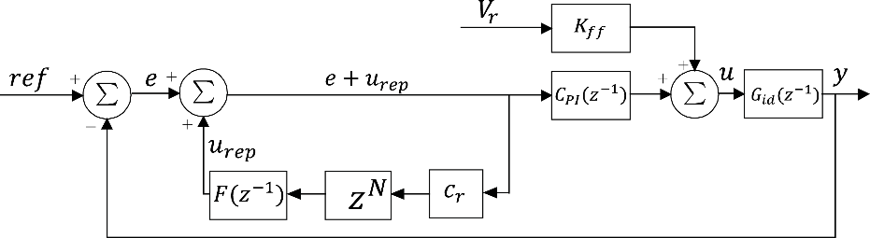

Figure 3.4- Block diagram of the proposed repetitive control strategy

The value of the repetitive controller gain  needs to be carefully selected as it is a key parameter for error convergence and system stability [POWER ELECTRONIC CONVERTERS FOR MICROGRIDS, SULEIMAN M. SHARKH, MOHAMMAD A. ABUSARA, GEORGIOS I. ORFANOUDAKIS, AND BABAR HUSSAIN]

A high  results in fast error convergence but reduces the system’s stability. A comparison between some different values of  is shown in Figure 3.5. It can be seen that, for values of  near unity, the peaks present in the magnitude plot and the abrupt changes of phase present on the phase plot of the bode diagram are very steep, while for values near zero, these characteristics are so smooth that the repetitive controller has almost no effect on the performance of the control system.

An adequate value of  is selected.

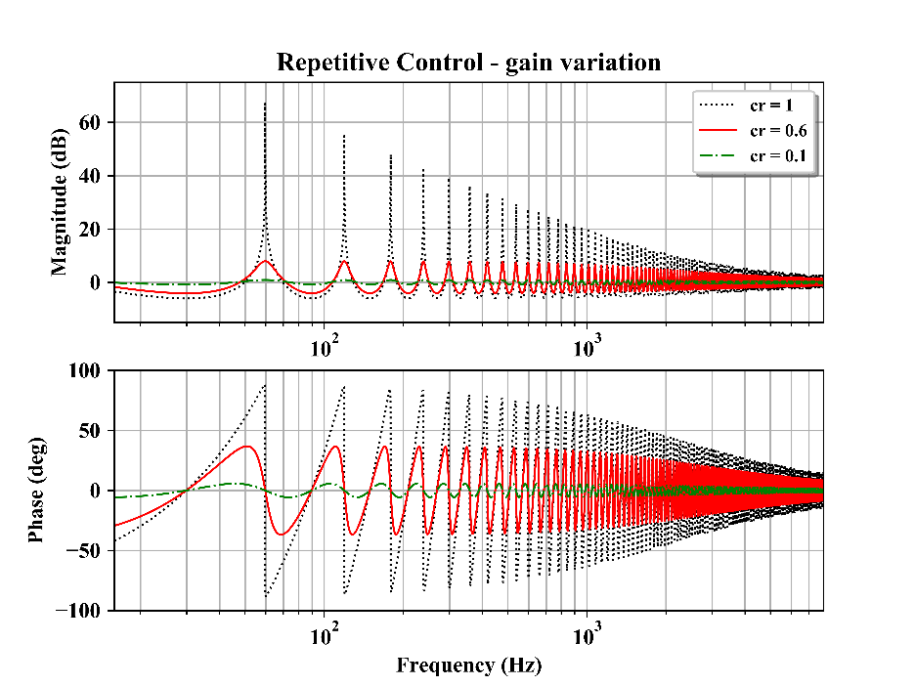

Figure 3.5- Comparison of repetitive control with different gains

The controller of instantaneous action of Figure 3.4 may have any known topology that guarantees satisfactory behavior to the system dynamics. A phase-advance compensators is used; it has the following structure:



Where

 is the frequency of the controller’s zero;

 is the frequency of the controller’s pole, which is chosen to be higher than $ω_{z}$;

 is the controller’s gain.

The Bode diagram of the open loop transfer function of the system, with $F\left(z^{-1}\right)=1$ is shown in FIGURE XXX.

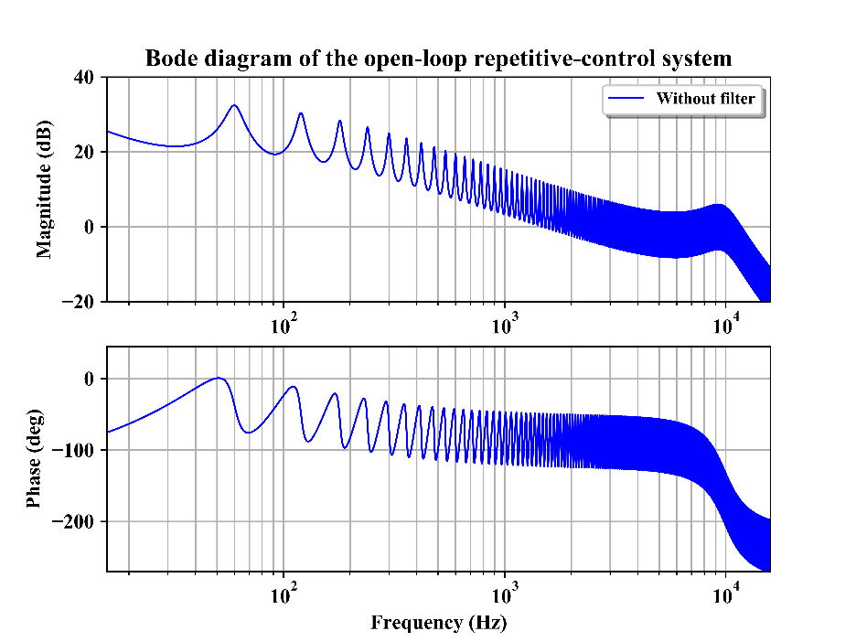

Figure 3.6- Frequency response of a repetitive control system with no filter

It can be noticed that the system is unstable due to the resonant peaks near the crossover frequency. It means that $F\left(z^{-1}\right)$ must be modified to attenuate high frequency peaks. A simple low-pass filter is used. It has the following structure:

$$F\left(s\right)=\frac{ω_{c}}{s+ω_{c}}$$

Where:

$ω_{c}$ is the cutoff frequency of the low-pass filter.

The cutoff frequency of the low-pass filter is chosen to be at 2 kHz in order to correctly attenuate the resonant peaks at the system crossover frequency. The resultant system’s bode diagram is shown in FIGURE XXX.

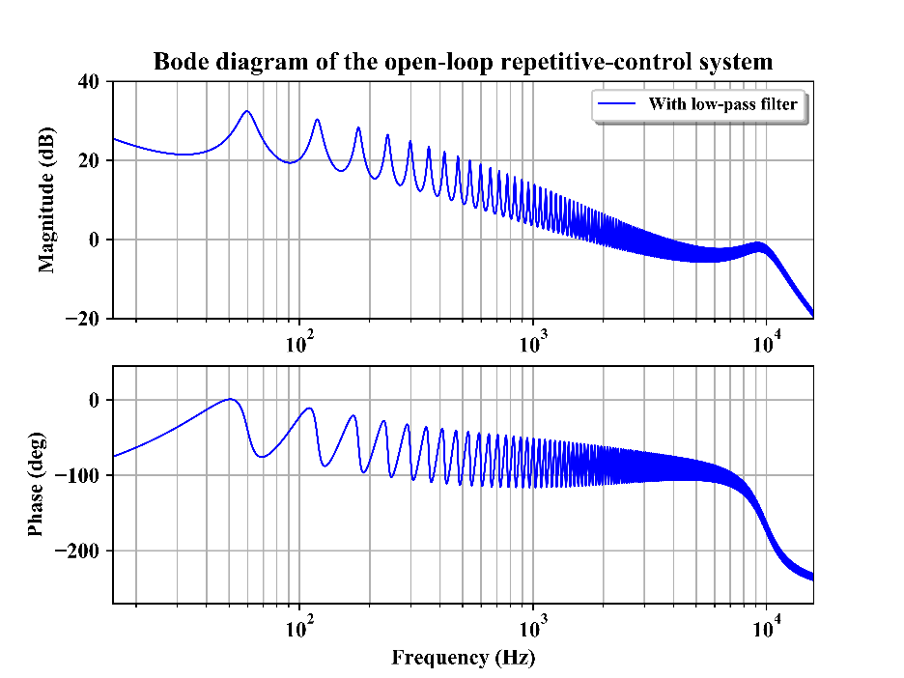

Figure 3.7- Frequency response of a repetitive control system with filter

It can now be noticed that, at the crossover frequency, the magnitude of the bode diagram is below 0 dB, which means that the system is stable.

**Auxiliary repetitive controller**

An alternative for the repetitive control is the auxiliary repetitive control, which is used only to improve the steady-state performance of the system, while the dynamic response and stability of the system is ensured by a conventional controller (PI, PD, PR, etc.).

It is important to note that any control strategy can be used for the stability and dynamic response of the system since the auxiliary repetitive controller is not dependent of the instantaneous control action.

[INSERT AN IMAGE HERE]

The transfer function of the auxiliary repetitive control action, used to generate periodic signals of multiple harmonics of a fundamental frequency is given by [EQUATION XXX]

$$G_{rp}\left(z\right)=\frac{U_{rp}\left(z\right)}{E\left(z\right)}$$

# HARDWARE IN THE LOOP VALIDATION

Usually, two main parts, the power stage and the controller unit, compose a power converter.

The power stage, which is composed by switches, power sources, inductors, capacitors, load, among other power components, represents the power plant that must be controller by the controller unit.

The controller unit, which is usually a set for the auxiliary circuits, contain auxiliary sources, integrated circuits (ICs), and a DSP or FPGA logic unit where the algorithms and control code are supposed to be digitally implemented.

Testing a digitally implemented code on its original power circuit is both very dangerous and expensive, since the power stage of a power converter usually operates with of either relatively high magnitudes of voltage or high magnitudes of current, or both.

Offline simulation [3] is generally used to prevent unexpected unforeseen events to happen, such as bad discretization of time-designed controls, unexpected behavior of the code under certain circumstances, bad logic implementation, or even a small mistake in the signal processing.

Though offline simulation is very effective in initial steps of implementation of a power converter, it does not cover all the aspects of the converter’s operation.

Also, to help test the implementation of the control unit, a low power version of the converter can be built to simulate the nominal operation of the real converter, but it will have different parameters than the original system [4].

A form of combining the advantages of the test methods explained so far is Hardware-in-the-Loop (HIL) simulation. HIL simulation provides realistic conditions like field testing, complex tests like laboratory tests, and low cost like offline simulation. It also allows for very rapid time-to-market of development of new technologies.

[INSERT HERE A FIGURE EXAMPLING DIFFERENT TEST METHODS]

Hardware-in-the-loop (HIL) simulation is a type of real time simulation. HIL simulation shows how the controller responds to realistic virtual signals. It is also used to check if the model of the physical system (plant) is valid.

The complexity of the plant under control is included in test and development by adding a mathematical representation of all related dynamic systems. These mathematical representations are referred to as the plant simulation.

FIGURE HERE

HIL simulation include emulation of sensors and actuators which act as the interface between the modeled plant and the embedded system under test. The value of each emulated sensor is controlled by the HIL simulation and read by the embedded system under test. Likewise, the embedded system outputs signals that are sent to the actuators on the plant simulation. Changes in the signal sent to the actuator results in changes to variable values in the plant simulation.

Summing up, a HIL simulation can be used to test the control technique chosen in a given application. With the use of a real-time computer as a virtual representation of the actual physical system and a real implementation of the controller used, one can test the embedded system before using it in a real hardware with actual components.

In this work, a Typhoon HIL 402 Hardware-in-the-loop system, shown in Figure 4.1, is used to test the different control techniques proposed to control the current injected into the grid. Typhoon HIL 402 has the specifications shown in Table 4.1.



Figure 4.1 - Typhoon HIL 402

Table 4.1- Specifications of HIL 402 from Typhoon HIL

|  |  |
| --- | --- |
| **HIL402 technical details.** | |
| Processor | 4 cores |
| Channels | 16 x Analog inputs (AI)  16 x Analog outputs (AO)  32 x Digital inputs (DI)  32 x Digital outputs (DO) |
| Resolution | 16 bit |
| Analog IO voltage range | ± 10 V |
| Built-in scope | Yes |
| Machine models support | Basic  Advanced |
| Connectivity | USB  Ethernet |
| Compatibility | HIL DSP Interface  HIL Breakout board  HIL dSpace Interface  HIL uGrid DSP Interface |
| Software | HIL Control Center |

Source: Typhoon HIL inc.

The interface connected to the Typhoon HIL 402 shown in Figure 4.1 was designed and assembled at INEP and the files related to it are presented in [APPENDIX C AND APPENDIX D]

The PWM signals used to command the switches of the converter are sent from a compatible Launchpad from Texas Instrument to the hardware through this interface, which is embedded with a signal buffer that adjusts the 3.3 V PWM signal from the Launchpad to the 5 V HIL input.

The interface board also adjusts the -10 – 10 V signals provided by the HIL 402 analog outputs to the 0 – 3.3 V signal that a Texas Instruments’ Launchpad is usually able to read in its analog inputs.

Some push-buttons and LED’s are also assembled in the interface board in order to improve the usability of the board.

The model used to represent the photovoltaic micro inverter feeding a resistive load with nominal power of 250 W is built in Typhoon HIL Control Center, and is shown in Figure 4.2.

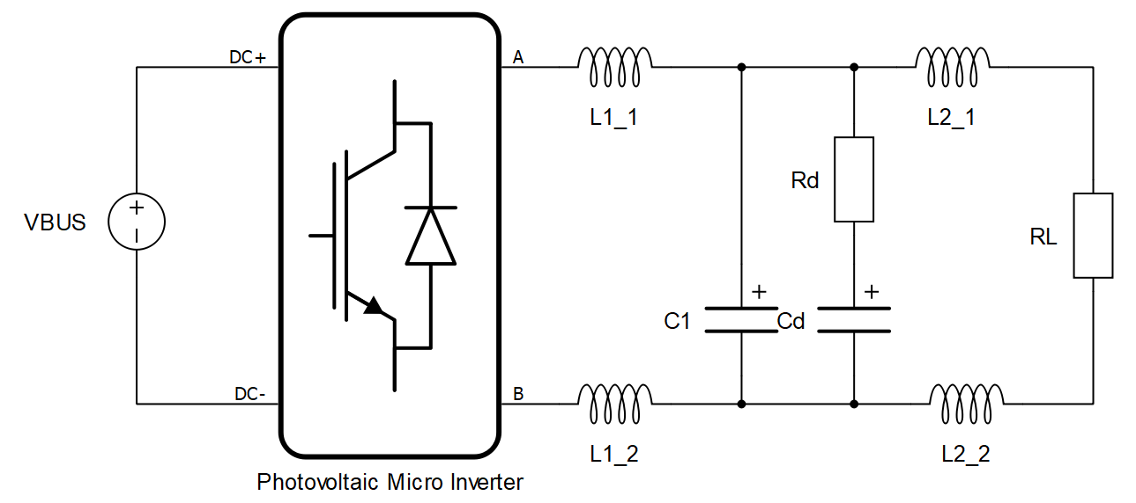

Figure 4.2 - Model of the micro inverter built in Typhoon HIL Control Center with resistive load

There are two options for controlling the Photovoltaic Micro Inverter switches of Figure 4.2: through digital inputs or using an internal modulator. Using HIL digital inputs means that the micro controller will command the inverter and, thus, the control technique that will be used in the physical prototype can be first tested in the HIL device.

## - Validation of the micro inverter model with a resistive load

In order to validate the model that will be used in HIL simulation, the circuit shown in Figure 4.2 is compared with the same circuit simulated in PSIM.

### - Open-Loop Operation with resistive load

The first method of validation of the HIL simulated system is the circuit shown in Figure 4.2, connected to a resistive load, operating in open-loop.

Figure 4.3 illustrates the current that flows through the inductors L2_1 and L2_2, which is the same current that is injected in the resistive load.

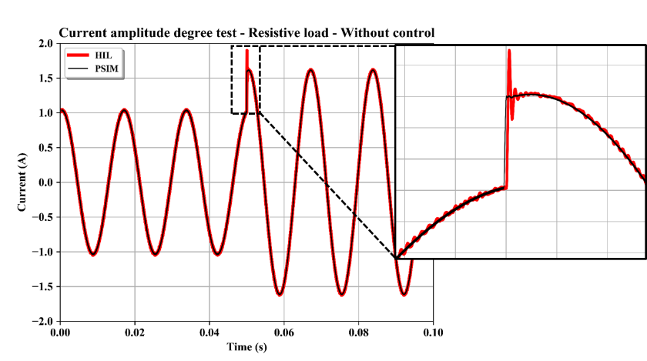

Figure 4.3 - Comparison between open-loop HIL and PSIM simulated results

Approximately at a simulation time of 50 ms, the amplitude of the current is changed from 1 A to 1.6 A.

The comparison shows that, when the system is operating in a steady-state, the response from HIL is similar to the response from PSIM.

However, when the amplitude of the current suddenly changes, one can observe that the two responses differ from each other. Therefore, the dynamic response of the HIL system is slightly different from the numeric-computer simulated system.

The difference in the HIL simulated system dynamic response may be explained by the fact that the simulation in the HIL system is optimized to run in real time.

By simulating a system in real time, in order to reproduce a large quantity of details from the real circuit, the simulation time step have to be smaller enough.

By optimizing the time step in a way that the HIL system can run in real time, some details may have to be neglected, and since non-linearities and complexities may be present [5], the difference between offline simulation and HIL simulation can sometimes be visible.

Reducing calculation time steps in HIL simulators is critical, especially if simulating lower power circuits or circuits with very low damping [4]. Faster calculation can be achieved with simpler models or lower resolution.

### - Independent Closed-Loop Operation with resistive load

The second method of validation of the HIL simulated system is the circuit shown in Figure 4.2, connected to a resistive load, operating in closed-loop with the same control structure.

Both systems are simulated under the PI control technique associated with a Feed-forward gain calculated in the previous chapter. The PI control continuous-time transfer function and the Feed-forward gain are given by and [XXXXXXX], respectively, and repeated in for convenience.



The discretized control law implemented in the micro controller is given by



Figure 4.3 illustrates the current that flows through the inductors L2_1 and L2_2, which is the same current that is injected in the resistive load.

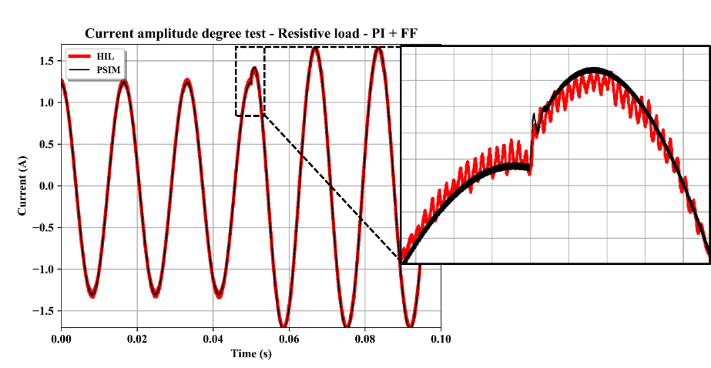

Figure 4.4 - Comparison between closed-loop HIL and PSIM simulated results with PI controller

### Independent Closed-Loop Operation connected to the grid

The third method of validation of the HIL simulated system is the circuit shown in Figure 4.5, connected to a voltage source emulating the electric grid, operating in closed-loop with the same control structure.

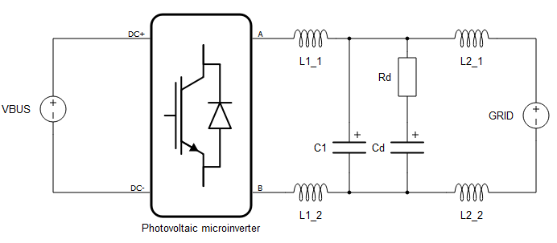

Figure 4.5 - Model of the grid-connected micro inverter built in Typhoon HIL Control Center

Both systems are again simulated under the PI control technique associated with a Feed-forward gain presented above for the second method of HIL validation.

The grid voltage source of both simulations is set to be as similar as the resolution of the HIL simulation allows. Thus, harmonics are inserted in these sources in order to more realistically emulate a real application

Figure 4.6 illustrates the current that flows through the inductors L2_1 and L2_2, which is the same current that is injected into the grid.

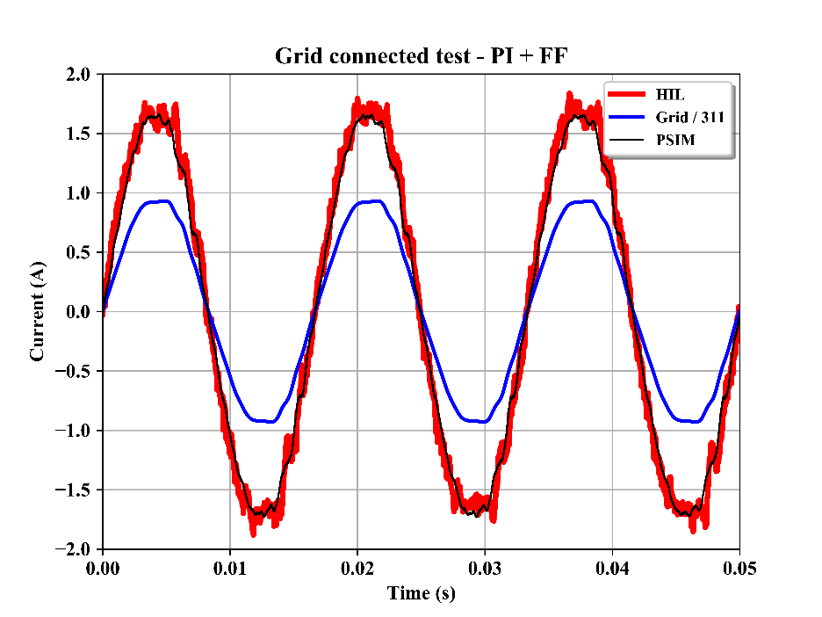

Figure 4.6 - Comparison between grid-connected closed-loop HIL and PSIM simulated results with PI controller

One can observe that HIL current waveform presents a higher ripple than PSIM waveform. Studies [4] and [5] suggest that this behavior may be caused by some factor, such as the low power of the system, high switching frequency, need for optimization of the variables for real-time calculation, among others.

In general, though, the HIL simulation results are satisfactory and allow testing the stability of different proposed control strategies and implementation of the real code to be run the photovoltaic micro inverter.

In the next sessions, the results obtained with Typhoon HIL 402 will be displayed and compared with the simulation results obtained with PSIM software through offline simulation.

## Energization and turning-on of the system

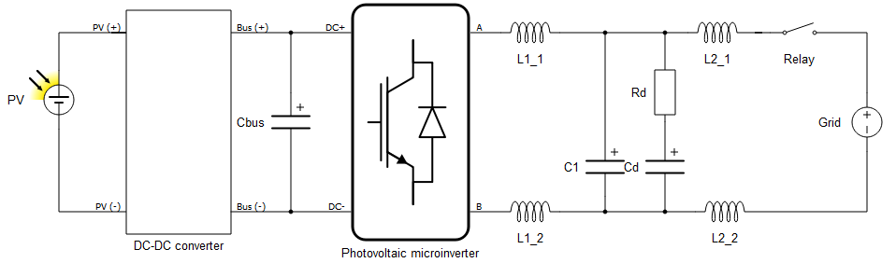

Figure 4.7 - Model of the full circuit of grid-connected micro inverter built in Typhoon HIL Control Center

The energization of this circuit is a crucial part of the operation of the micro inverter connected to the grid. Each step must be carefully designed so that every procedure involving the connection to the grid to occur without any failure.

Steps for the micro inverter to connect to the grid are:

1. Initially, the controller unit checks the grid characteristics through the PLL algorithm, assuring that the voltage is within the range of 176 to 242 Vrms.
2. When the Turn-On button is pressed, the ramp up the voltage of the bus is initiated, which must initially be the same as the open-circuit voltage of the installed photovoltaic module.
3. Bus voltage must reach the nominal value, which is 420 V. If that does not happen within 30 seconds, an error must occur and turn off the micro inverter
4. Connection to the grid. If previous steps occur without setbacks, the relays that connect the grid to the micro inverter circuit are energized and start to conduct. Since the micro inverter’s switches are still without command pulse, a current flows through the mash presented in FIGURE XXX
5. Enable micro inverter’s switches and grid current control law. After some idle time, the control law that commands the switches of the micro inverter starts to calculate the desired duty cycle and send the PWM signal to the switches. This effectively regulates the control so that it has the peak value that would balance the power the power generated by the photovoltaic panel and the power injected into the grid.
6. Steady state operation of the system. In this stage, protections related to the grid characteristics, current injected into the grid, bus voltage, photovoltaic panel voltage, and all the protections are constantly checked every two commutation periods.
7. To turn the micro inverter off it is necessary to press a button connected to a micro controller input.

FIGURA DO PASSO 4 AQUI.

## HIL assisted Validation of protections

If any variable is not within a safe range of operation, an error must occur and stop the operation of the entire prototype.

In order to validate these protections, the errors that activate them can be simulated with assistance of Typhoon HIL software.

# CONCLUSÃO

As conclusões devem responder às questões da pesquisa, em relação aos objetivos e às hipóteses. Devem ser breves, podendo apresentar recomendações e sugestões para trabalhos futuros.

###### REFERÊNCIAS

Conjunto padronizado de elementos descritivos retirados de um documento, que permite sua identificação individual (ASSOCIAÇÃO BRASILEIRA DE NORMAS TÉCNICAS, 2011).

ALVES, Maria Bernardete Martins; ARRUDA, Susana Margareth. **Como fazer referências**: bibliográficas, eletrônicas e demais formas de documento. Florianópolis: Universidade Federal de Santa Catarina, Biblioteca Universitária, c2001. Disponível em: <http://www.bu.ufsc.br/design/framerefer.php>. Acesso em: 11 abr. 2013.

ASSOCIÇÃO BRASILEIRA DE NORMAS TÉCNICAS. **NBR 10520**: informação e documentação: citações em documentos: apresentação. Rio de Janeiro, 2002.

­­­­______. **NBR 6024**: informação e documentação: numeração progressiva das seções de um documento escrito: apresentação. Rio de Janeiro, 2012.

______. **NBR 14724**: informação e documentação: trabalhos acadêmicos: apresentação. Rio de Janeiro, 2011.

INSTITUTO BRASILEIRO DE GEOGRAFIA E ESTATÍSTICA. Normas de apresentação tabular. Rio de Janeiro: [S.n.], 1993. 60 p.

UNIVERSIDADE FEDERAL DE SANTA CATARINA. Biblioteca Universitária. **Trabalho acadêmico: guia fácil para diagramação**: formato A5. Florianópolis, 2009. Disponível em: <http://www.bu.ufsc.br/design/GuiaRapido2012.pdf>. Acesso em: 11 abr. 2013

###### APPENDIX A – Influence of control strategies on the micro-inverter operation considering parasitic resistances of inductors

In terms of DC current injection into the grid, one must analyze the influence that different control strategies have on the converter operation when parasitic resistances of the filter inductors are considered.

Figure 5.1 shows a block diagram for a discrete-time, PWM modulated system. For the analysis presented in this appendix,  is considered unitary.

The delay caused by the zero-order holder (ZOH) is not considered in this case because it is too small compared to the dynamic analyzed.

The PWM gain is also considered unitary in this system.

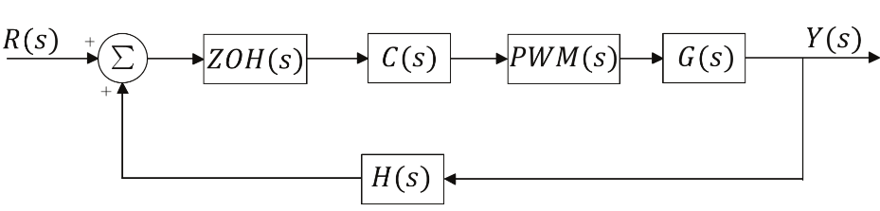

Figure 5.1 - SISO feedback control system

Final value theorem provides a convenient manner of determining the stationary performance of a stable system. The stationary acting error of a system is given by .



The error  can be written as .



But the output  is defined as



Which yields .



The error signal  can finally be rewritten in the form of .



Since this analysis is considering the stationary error, the reference signal  is given by



The stationary error given by Equation can be calculated in Equation





The error is a function of the terms and . can be found by analyzing the bode diagram of the transfer function that relates the current injected into the grid by the duty cycle.

In order to find this transfer function, one must take into consideration the intrinsic resistance of the inductors in the output filter. That way, analysis made in chapter 2 of this dissertation must be remade.

The impedances of the circuit can be mathematically described, utilizing the Laplace variable  by Equations, , and







The new transfer function that relates the duty cycle with the current in the second inductor considering the inductor´s resistance is given by :



System analysis

Figure 5.2 shows the difference on the frequency response of the micro inverter transfer function when the parasitic inductor´s resistances are taking into consideration in opposition with when the circuit is considered ideal.

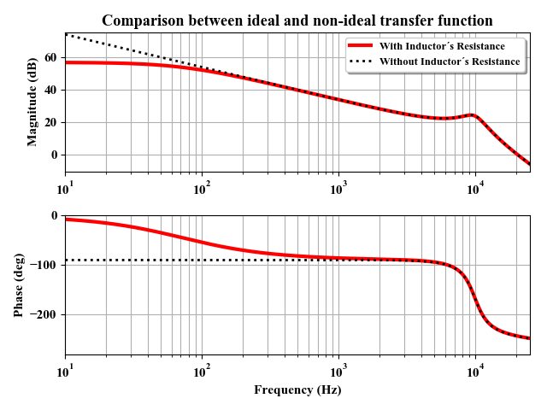

Figure 5.2 - Difference in the frequency response of the circuit transfer function

The difference in these two systems appear on low frequencies. On the ideal system, the low frequency gain is infinite. In the non-ideal system, the low frequency gain tends to a finite value.

For this case, it was considered the measured values of the inductor resistance of inductors  and . The low frequency gain of the system is about .

Control Strategies analysis

**Proportional**

The gain of the proportional controller is constant through the entire frequency range. Therefore, for low frequencies, the gain of this controller equals .

For the controller chosen in this thesis, this gain is 

**Proportional + Integral**

The gain of the proportional + integral (PI) controller is ideally infinite for low frequencies. That is, the gain of this controller in low frequency tends to .

**Proportional + Resonant**

The gain of the proportional + resonant (PR) controller can be approximated as the proportional gain for low frequencies. That is, the gain of this controller in low frequency tends to .

For the controller chosen in this thesis, this gain is 

**Proportional + Multi-Resonant**

The gain of the proportional + multi-resonant (MR) controller, as in the case of the PR controller, can be approximated as the proportional gain for low frequencies. That is, the gain of this controller in low frequency tends to .

For the controller chosen in this thesis, this gain is 

**Proportional + Integral + Repetitive**

The repetitive controller, associated with a PI controller follows the same logic presented for the PI controller itself. That is, the gain of this controller is ideally infinite for low frequencies and tends to .

Error analysis

All elements of Equation are known and one can calculate the influence of the control strategy on the system for low frequency perturbations.

**Proportional**

By replacing the system and the proportional control low-frequency gain in Equation , one can obtain the error for DC values for proportional controller:



**Proportional + Integral**

By replacing the system and the PI control low-frequency gain in Equation , one can obtain the error for DC values for PI controller:



**Proportional + Resonant**

By replacing the system and the PR control low-frequency gain in Equation , one can obtain the error for DC values for PR controller:



**Proportional + Multi-Resonant**

By replacing the system and the MR control low-frequency gain in Equation , one can obtain the error for DC values for MR controller:



**Proportional + Integral + Repetitive**

By replacing the system and the repetitive control low-frequency gain in Equation , one can obtain the error for DC values for repetitive controller:



###### ANEXO A – Descrição

São documentos não elaborados pelo autor, que servem de fundamentação (mapas, leis, estatutos). Deve ser precedido da palavra ANEXO, identificada por letras maiúsculas consecutivas, travessão e pelo respectivo título. Utilizam-se letras maiúsculas dobradas, quando esgotadas as letras do alfabeto.